**Experiment - 1**

**AIM:** Introduction to SCILAB and implementation of basic operations in Scilab.

**Theory:**

## What is Scilab?

Scilab is a free and open-source software for engineers & scientists, with a long history (first release in 1994) and a growing community. Scilab is mainly developed by the Scilab team within ESI Group SCILAB is a numerical, programming, and graphics environment available for free from the French Government's "Institut Nationale de Recherche en Informatique et en Automatique - INRIA (National Institute for Informatics and Automation Research)." It is similar in operation to MATLAB and other existing numerical/graphic environments, and it can be run using a variety of operating systems including UNIX, Windows, Linux, etc. SCILAB is a self-contained package including a large number of intrinsic numeric, programming and graphics functions.

**Basic Calculations:**

1. Enter simple arithmetic expressions in the Console, like 2 + 3, and press Enter. Scilab will show the result (5) below the expression.
2. Try other calculations, including *, /, -, ^ (exponentiation), and sqrt (square root).

**Variables and Data Types**

Assign a value to a variable using the = symbol. For example, type a = 10 and press Enter. Now, a stores the value 10.

**Vectors and Matrices:**

Create a vector (one-dimensional array) by enclosing elements in square brackets, separated by commas. For example, type v = [1, 2, 3, 4] to create a vector named v with four elements.

**Output:**

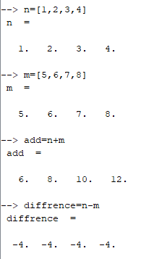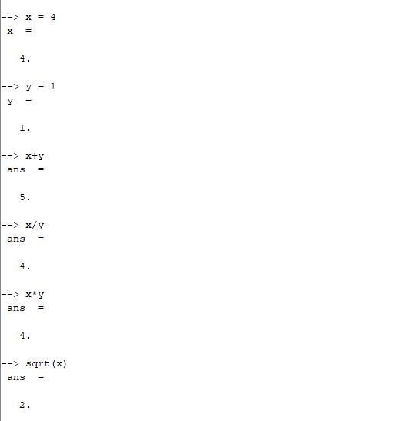

**Experiment - 2**

**AIM:** Exercises to implement the basic matrix operations in Scilab.

**Theory:**

1. **Creating Matrices:**

* Use the zeros() function to create a 3x4 matrix of zeros. Assign it to a variable named A.
* Use the ones() function to create a 2x3 matrix of ones. Assign it to a variable named B.
* Use manual entry to create a 4x2 matrix

1. **Matrix Addition and Subtraction:**

* Perform element-wise addition of matrices A and C. Assign the result to a variable named D.
* Perform element-wise subtraction of matrix B from matrix C. Assign the result to a variable named E.

1. **Matrix Multiplication:**

* Perform matrix multiplication of A and C. Assign the result to a variable named F.

1. **Matrix Transpose:**

* Find the transpose of matrix B. Assign the result to a variable named G.

1. **Matrix Inverse:**

* Find the inverse of matrix C. Assign the result to a variable named H.

**Output:**

